Program: BE Electronics Engineering
Curriculum Scheme: Revised 2016
Examination: Third Year Semester VI
Course Code: EXC 603 and Course Name: VLSI DESIGN
Time: 1 hour Max. Marks: 50
==============================================================================
Note to the students: - All the Questions are compulsory and carry equal marks.
Q1. | In layout diagram which material is used for gate
Option A: | Polysilicon
Option B: | Si
Option C: | Ge
Option D: | GaAs
Q2. | In constant voltage scaling which parameter is constant
Option A: | voltage
Option B: | current
Option C: | power
Option D: | Voltage & current
Q3. | In voltage transfer characteristics of MOSFET inverter V_{IH} indicates
Option A: | Cut off point
Option B: | Critical point
Option C: | Saturation point
Option D: | Depletion point
Q4. | Difference between Flip flop & latch is
Option A: | In flip flop clock is used
Option B: | In latch clock is used
Option C: | In flip flop & latch clock is used
Option D: | Clock is not used in flip flop & latch both
Q5. | In voltage transfer characteristics of MOSFET inverter V_{OH} indicates
Option A: | Max output voltage when output level is logic 0
Option B: | Minimum output voltage when output level is logic 0
Option C: | Max output voltage when output level is logic 1
Option D: | Minimum output voltage when output level is logic 1
Q6. | What VTC indicates in CMOS inverter
Option A: | Voltage transfer characteristics
Option B: | Voltage transient characteristics
Option C: | Voltage time characteristics
Option D: | Voltage timeline characteristics
Q7. | I_{D}=µC_{OX} W/L(V_{GS}-V_{TH})² the MOSFET will work in
Option A: | Cut off region
Option B: | Active
Option C: | Saturation
Option D: | Depletion
Q8. | Correct symbol of CMOS
Option A: | 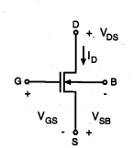
Option B: | 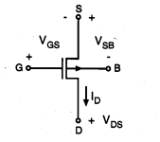
Option C: | 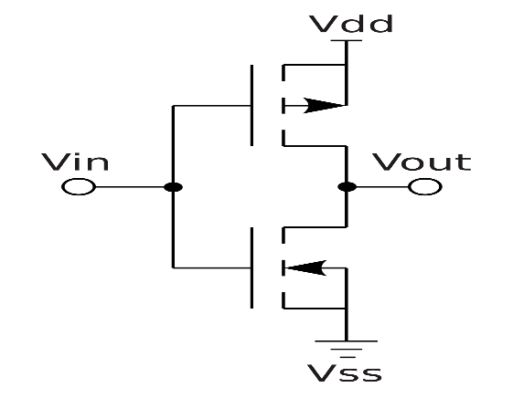
Option D: | 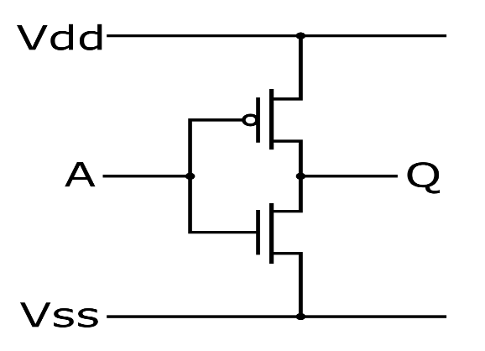
Q9. | RCA vs CLA
Option A: | delay of RCA is high
Option B: | Delay of CLA is high
Option C: | delay of both are same
Option D: | there is no delay in RCA
Q10. | D flip flop is also called as
Option A: | Delay flip flop
Option B: | dead flip flop
Option C: | deadline flip flop
Option D: | Double flip flop
Q11. | Channel length modulation parameter is
Option A: | λ
Option B: | Ω
Option C: | Δ
Option D: | β
Q12. | CCMOS stands for
Option A: | Complementary CMOS
Option B: | Clocked CMOS
Option C: | Control CMOS
Option D: | Complementary symmetry CMOS
Q13. | In Precharge & evaluate logic
Option A: | Common clock is given
Option B: | Different clock is given
Option C: | Clock is not given for Precharge logic
Option D: | Clock is given only for evaluate logic
Q14. | How many transistors are used in DRAM
Option A: | 5
Option B: | 6
Option C: | 4
Option D: | 3
Q15. | Which architecture is used to design VLSI
Option A: | System on device
Option B: | Single open circuit
Option C: | System on chip
Option D: | System on a circuit
Q16. | Which provides higher integration density?
Option A: | Switch transistor logic
Option B: | Transistor buffer logic
Option C: | Transistor transistor logic
Option D: | System on device
Q17. | Charge sharing problem occurs in
Option A: | Dynamic logic
Option B: | Pseudo logic
Option C: | Static
Option D: | CCMOS
Q18. | PROM stands for
Option A: | Programmable ROM
Option B: | Program ROM
Option C: | Primary ROM
Option D: | Programmable random access memory
Q19. | The component used for DRAM is
Option A: | Capacitor
Option B: | Resistor
Option C: | Inductor
Option D: | metal
Q20. | The expression for carry in half adder is
Option A: | AB
Option B: | A’B
Option C: | AB’
Option D: | A’B’
Q21. | In CMOS inverter
Option A: | 1 NMOS & 1 PMOS is used
Option B: | 2 NMOS used
Option C: | 2 PMOS used
Option D: | 4 NMOS used
Q22. | Difference between static & dynamic CMOS
Option A: | Both are same
Option B: | In static clock is used
Option C: | In dynamic logic clock is used
Option D: | Extra transistors are used in static RAM
Q23. | CMOS behaves like
Option A: | AND GATE
Option B: | OR
Option C: | NOT
Option D: | EXOR
Q24. | In realization of Y=A+B how many transistors are required?
Option A: | 6
Option B: | 4
Option C: | 5
Option D: | 1
Q25. | In realization of Y=A*B how many transistors are required?
Option A: | 6
Option B: | 4
Option C: | 5
Option D: | 1

